Case 2: UCR Medical Center Volunteer

Team Name: Script Users

Team Members: Luis Garibay & Jrrobert Jabonillo

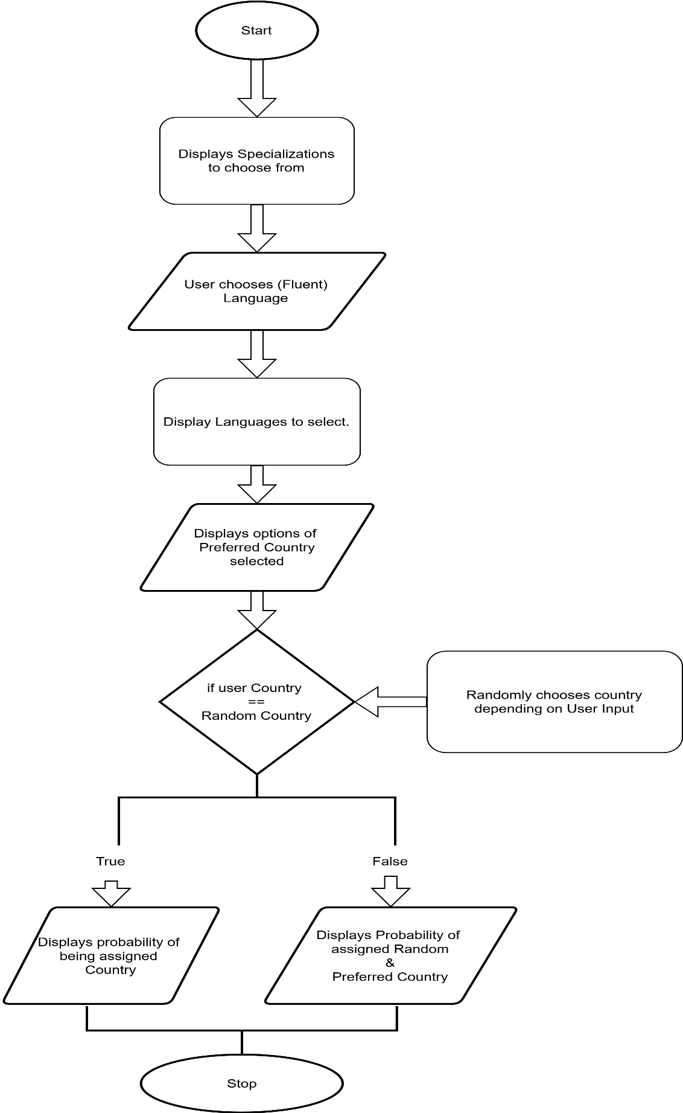FlowChart: